Assignment 1: Linux_Basics_Vanita

1. Creating and Renaming Files/Directories
- Create a directory named test_dir using mkdir – mkdir used to create directory
- Inside test_dir, create an empty file called example.txt – touch command is used to create empty file.
- Rename example.txt to renamed_example.txt using mv – mv command is ued to move or rename file or folder
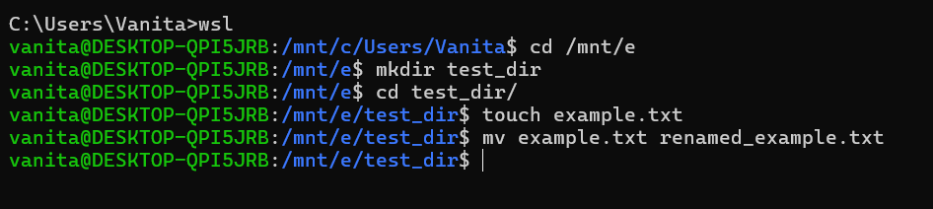

2. Viewing File Contents
- Use cat to display the contents of /etc/passwd – cat command is used to view content of the file.
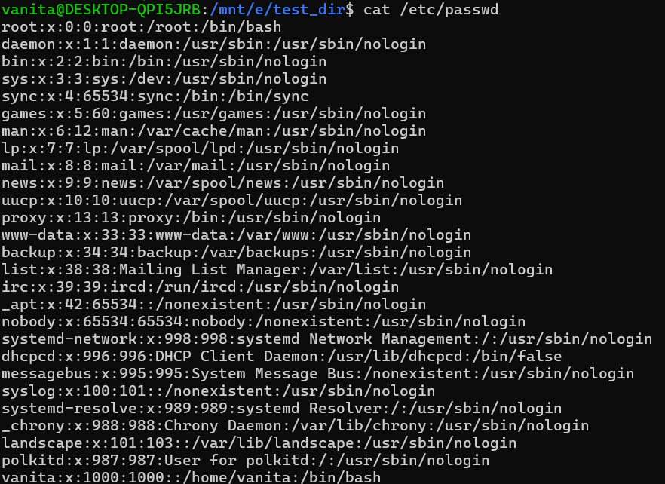
- Display only the first 5 lines of /etc/passwd using head – using cat to display and head for view first 5 lines.
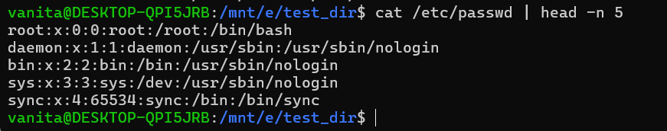
- Display only the last 5 lines of /etc/passwd using tail – tail command is used for retrieving bottom lines.
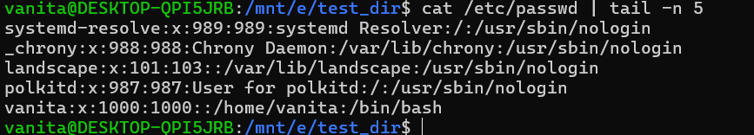

3. Searching for Patterns
- Use grep to find all lines containing the word “root” in /etc/passwd – grep is used to find the keyword in a file.

4. Zipping and Unzipping
- Compress the test_dir directory into a file named test_dir.zip using zip – Since there is no zip package I have installed using sudo apt update and then sudo apt install zip later I zipped it using zip command.
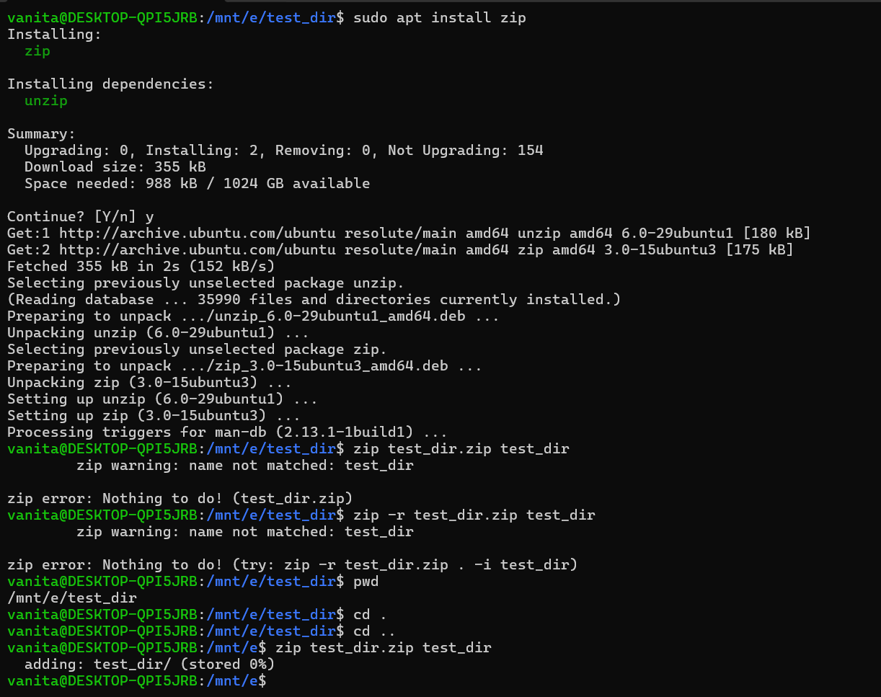

- Unzip test_dir.zip into a new directory named unzipped_dir – unzip command to unzip the folder with specific path or folder.

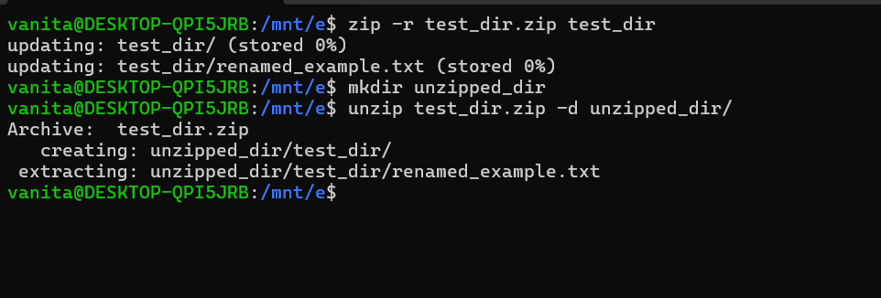

5. Downloading Files
- Use wget to download a file from a URL (e.g., https://example.com/sample.txt) – wget is used for downloading a file
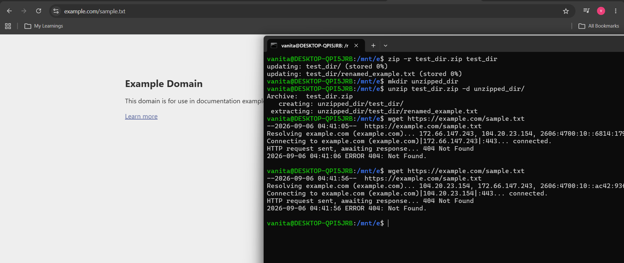

6. Changing Permissions
- Create a file named secure.txt and change its permissions to read-only for everyone using chmod.
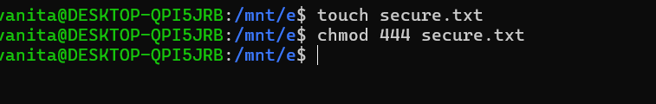
7. Working with Environment Variables
- Use export to set a new environment variable called MY_VAR with the value “Hello, Linux!” – export command is used to set variable but it will work in this terminal only and if I open new terminal it will not work as it is temporary.
